Customer Shopping Behavior Analysis

1.Project overview:
This project analyzes customer shopping behavior using transactional data from 3,900 purchases across various product categories. The goal is to uncover insights into spending
Patterns , customer segments, product preferences. And subscription behavior to the guide strategic business decisions.

2.Dataset Summary:
-Rows: 3900
-Columns: 18
-Key Features:
-Customer demographics (Age, Gender, Location, Subscription Status)
-Purchase details(Item Purchased, Category, Purchase Amount, Season, Size, Color)
-Shopping Behavior(Discount Applied, Promo Code Used, Previous Purchases, Frequency of Purchases, Review Rating, Shipping Type)
-Missing Data: 37 values in Review rating column

3. Exploratory Data Analysis
We began with data preparation and cleaning in python
- Data Loading: Imported the dataset using pandas.

- Initial Exploration: Used df.info( ) to check structure and describe( ) for summary statistics

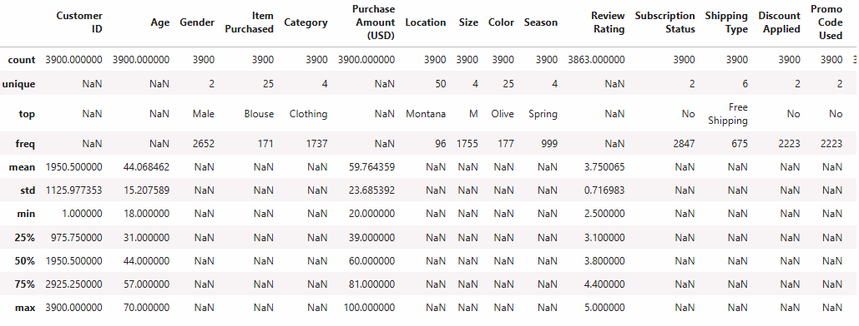
- Missing Data Handling: Checked for null values and imputed missing values in the Review Rating column using the median rating of each product category.

- Column Standardization: Renamed columns to snake case for better readability and documentation

- Feature Engineering:
        - Created age_group column by binning customer ages.
        - Cretaed purchase_frequency_days column from purchase data

- Data consistency Check: verified if discount_applied and promo_code_used were redundant;dropped promo_code_used

- Database Integration: Connected python Script to PostgreSQL and loaded the cleaned DataFrame into the database for SQL analysis

4.Data Analysing using SQL (
We performed structure analysis in PostgreSQL to answer key business questions:
- Revenue by Gender : -Compared total revenue generated by male vs female customers

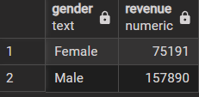

- High Spending Discount Users: -Identified Customers who used discounts but still spent above the average purchase amount

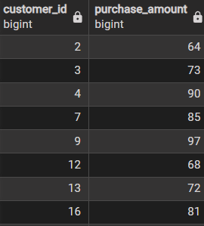

- Highest Average Review Rating: Top 5 Products with highest average rating

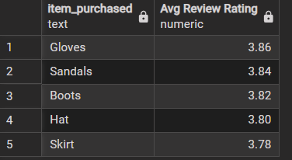

- Shipping type comparision: comparing the purchase amounts between standard and express shipping

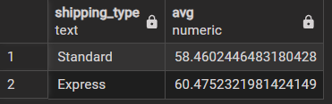

- Subscribers Vs Non-Subscribers: comparing average spend and total revenue between subscribers and Non-subscribers

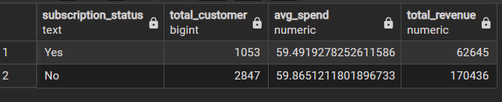

- Discount Dependent Purchases: Top 5 products have the highest percentage of purchases with discounts applied

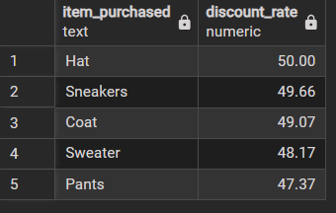

- Customer Segmentation: segmenting the customers into New , Returning, and Loyal based on their total no of previous purchases and show the count of each segments

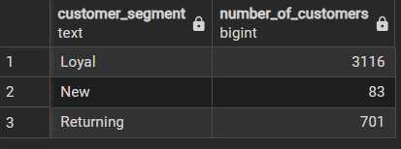

- Top 3 products per category: Top 3 products purchased with in the each category

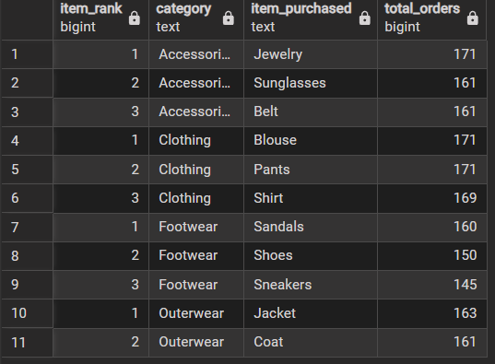

- Repeat Buyers and Subscribtion: checked whether customers with >= 5 purchases are likely to subscribe

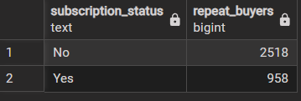

- Revenue By Age Group: Revenue contribution by each group

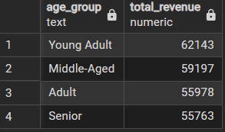

5. Dashboard:

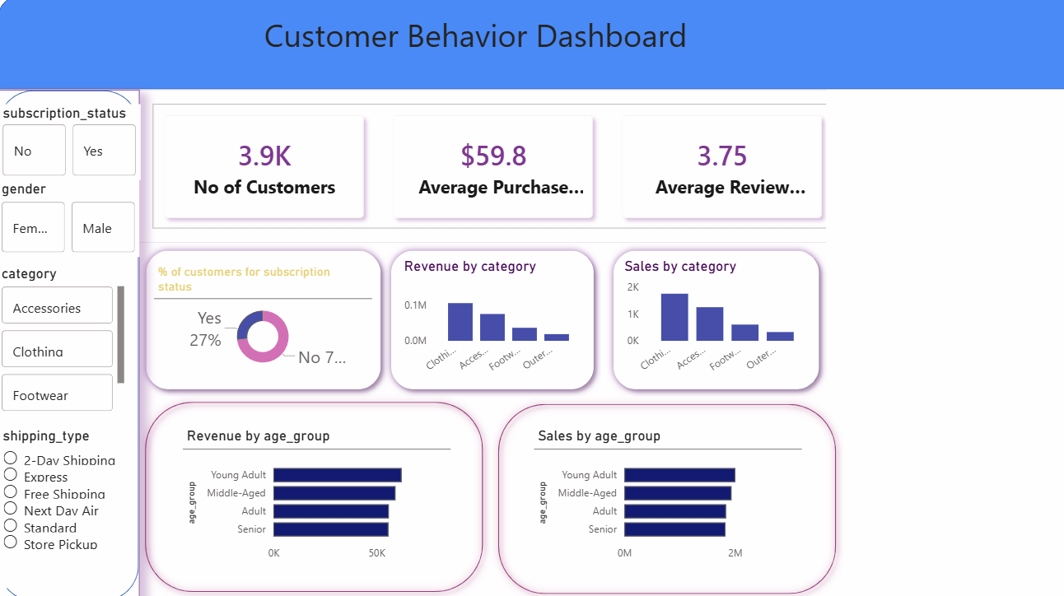

6.Business Recommendations:
  - Boost subscriptions - promote exclusive benefits for subscribers.
  - Customer Loyalty Programs - Reward repeat buyers to move them into “Loyal” segment
  - Review Discount policy - Balance sales boosts with margin control.
  - Product Positioning - Highlight top-rated and best-selling products in campaigns.
  - Targeted marketing – Focus efforts on high-revenue age groups and express-shipping users.

